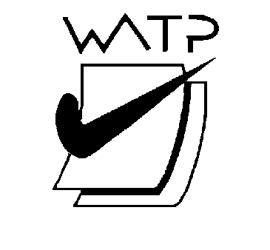

West Australian Test Papers

PHYSICS

Year 12

2005

SOLUTION BOOKLET

&

MARKING GUIDE

Markers should note that the solutions presented here are skeletal answers and should be used as a guide only.

Alternate answers used by students may be perfectly acceptable and discretion should be used.

Section A
Q1 15 waves in 190 s
Period is time for 1 wave = 10/15 = 0.66 s

Q2 In a longitudinal wave the direction of the energy transfer is in the same direction as the direction of propagation but in transverse waves the direction is at right angles.

Q3 When the ball leaves the teacher’s hand the only force acting on the ball is the force of gravity. This force accelerates the ball vertically downwards. The change in speed is in the vertical direction.

Q4 The orbits in diagram C are not possible because the centripetal force to hold them in orbit must act towards the centre of the circle. In diagram C this force is not acting towards the centre of the earth.

Q5 The emission spectra is due to transitions between the energy levels of sodium. They are discrete so the changes in energy are well defined. Since this change in energy results in a line of frequency (f) given by E = h f, then we see a few sharp coloured lines for sodium. The absorption spectrum of the sun is due to molecular motion in the sun and is a continuous spectrum. The few dark lines are due to absorption due to elements in the sun / earth atmosphere and they are discrete.

Q6
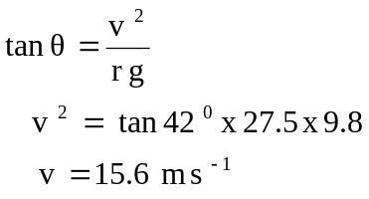

Q7 a) 9.92 x 10⁻¹⁹ / 1.6 x 10⁻¹⁹ = 6.2 eV This corresponds to a transition between n = 2 and n = 1

b) The shortest wavelength has the largest frequency which corresponds to the largest ΔE, so the line would be drawn between n = 4 and n = 1.

Q8 m v² = mg
r
v² = r g v = 22.1 m s⁻¹

Q9 (i) A is in tension and B is in compression. So the answer is ‘B’

- A reinforcement rod that is in the shape of a sine wave should be part of the beam along its entire length.
Concrete has very large compression strength but is lower in tensile strength. Therefore the reinforcing rod of the shape suggested above will reduce the tendency of the beam to curve downwards where it overhangs the columns.
OR pre-tensioned rod inserted near the top of the beam.
Q10 The cables are suspended between pylons so are under tension and liable to stretch. Steel has a greater Young’s Modulus than aluminium so the steel offers greater support to the cable which consists largely of aluminium because it is a better electrical conductor than steel and is also lighter.

Q11 (i) Y = stress / strain
Y = 10⁸ / 1.4 x 10⁻³
Y = 7.14 x 10¹⁰ N m⁻²

(ii) 7.14 x 10¹⁰ = (force / area) x (l / Δl)
Δl = (12 500 x 100) / (10 x 10⁻⁶ x 24 x 7.14 x 10¹⁰)
Δl = 7.3 x 10⁻² m

Q12 V_{p} / V_{s} = n_{p} / n_{s}

240 / 3 = 1200 / n_{s}

n_{s} = 15 turns

Q13 speed of sound in air = 346 m s⁻¹
17 cm represents 0.25 of a wavelength
Therefore the wavelength is 4 x 17 cm = 68 cm = 0.68 m
speed = λ x f
- = 0.68 x f
f = 346 / 0.68 = 508 Hz

Q14 (a) When the angle θ is large the clockwise moment is less than when the angle θ is small and only friction can oppose this moment. The frictional force is limited so the ladder is less likely to slip when the angle θ is smaller.

- The two forces on the ladder will be the weight of the ladder acting through the centre of mass and the reaction of the gutter on the ladder. The students may also include the resulting reaction force of the ground on the ladder.

Q15 F = B q v
F = 2 x 10⁻³ x 3 x 10⁶ x 1.6 x 10⁻¹⁹
F = 9.6 x 10⁻¹⁶ N

Using the right hand rule, the direction is towards the WEST.

Section B
Q1 (a) power = 1.8 x 10⁴ / 60 = 300 W

- Intensity = 5.0 x 10⁻⁹ / 4.0 x 10⁻⁵ = 1.25 x 10⁻⁴ W m⁻²

(c) (ii) Period = 4 x 10⁻³ s

  - frequency = 1/ (4 x 10⁻³) = 250 Hz

speed = λ x f
346 = λ x 250
λ = 1.38 m

  - As temperature increases so does the speed of sound. As frequency remains constant then the wavelength would increase.
(d) D

- The path difference is 28.75 – 24.60 = 4.15 m
The wavelength is 1.38 m
4.15 / 1.38 = 3.00
This means the waves are in phase so a maximum intensity (D) is experienced.

Q2 (a) (i) F = m v² / r v² = 2 Π x 0.55 so v = 51.8 m s⁻¹
(1 / 15)

F = 1.5 x 51.8² / 0.55

F = 7.32 x 10³ N which is the force quoted in the question.

- Stress = force / area

7.32 x 10² / 3.5 x 10⁻⁴

= 2.09 x10⁷ Pa

- Young’s Modulus for aluminium is 0.7 x 10¹¹
0.7 x 10¹¹ = stress / strain
Strain = 2.09 x 10⁷ / 0.7 x 10¹¹ = 2.99 x 10⁻⁴

Dl / l = 2.99 x 10⁻⁴

Dl = 0.55 x 2.99 x 10⁻⁴

Change in length is 1.64 x 10⁻⁴ m

(b) The blade that is pointing downwards is experiencing the greatest force. When it is in this position it is experiencing both a centripetal force acting down as well as the gravitational force. These two forces are acting in the same plane so can be added to provide the blade with a greater net force than the three other blades.

3 (a) (i) Advantages include:
The forces on the horizontal section of the structure are reduced
The vertical load on the structure is distributed more evenly over the horizontal components of the structure.

- Take moments about C

Weight = 5.00 x 10⁵ N
The vertical force supported by the RHS buttress = 2.5 x 10⁵ N
Let the distance from C to M (the perpendicular distance between the pivot and the line of action of the force that exists in length M is d) is calculated by: (cos 30º = d / 2.5)
So d is 2.165 m

Sum of the clockwise moments = sum of anticlockwise moments
(Force along M) x 2.165 = 2.5 x 2.5 x 10⁵
Force along M = 2.5 x 2.5 x 10⁵ / 2.165
Force along length M = 2.91 x 10⁵ N

(b) (i) Perpendicular distance from X to line of action of
wire (W) is 4.33 m
By taking moments about X
Sum of the clockwise moments = sum of anticlockwise moments
200 x 4.33 = (R x 2) + (8.0 x 9.8 x 2.5)

R = [(200 x 4.33) - (8.0 x 9.8 x 2.5)] / 2 = 335 N

Tension force in the rope R is 335 N

4 (a) (i)
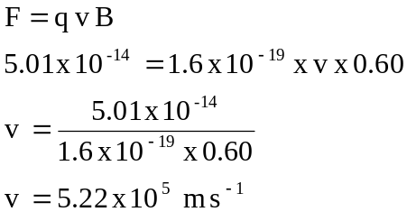

- r = mv / Bq

(0.38 / 2) = (m x 5.22 x 10⁵⁾ / (0.6 x 1.6 x 10⁻¹⁹)

m = 3.494 x 10⁻²⁶ kg

mass = 3.494 x 10⁻²⁶ / 1.66 x 10⁻²⁷ = 21.05 u

This is approximately = 21 which is the isotope Ne-21

4 (b)
Incandescent
Method - Current flows through tungsten filament and it glows white hot.
Spectrum - Continuous but with greater amount of red
Efficiency - Approx 8%
Use - General lighting where a ‘warm’ feeling is needed.

Low Pressure Sodium
Method – Electrons from a cathode filament pass through sodium vapour where they collide with sodium atoms. The electrons in these atoms are raised to higher energy levels. As they return to the ground state they emit visible yellow light.
Spectrum - line emission spectrum containing 2 yellow lines called the sodium doublet.
Efficiency - approx 80%
Use - Crosswalks, street lighting. Makes pedestrians more visible.

5(a) (i) V_{p} / V_{s} = n_{p} / n_{s}

220 kV / 10 kV = n_{p} / n_{s}

The ratio is 22 :1

- Ip x Vp = Is x Vs
    - x 10⁶ = Is x 10 x 10³
Is = 50 A

(b) (i) Total current in line = 16 A
Power loss = I² x R
16² x (0.0004 x 2000) = 205 W

(ii)
V _{loss} = I x R_{loss}

V _{loss} = 16 x (0.0004 x 2000)
V _{loss} = 12.8 V
Voltage at the Smith farm is 240 - 12.8 = 227 V

  - (a) 15 000 x 2.5 = 3.75 x 10⁴ N m

- Take moments about P

Sum of ACM = Sum of CM
2 x (weight of load) = 3.75 x 10⁴

Maximum load = 1.88 x 10⁴ N

- The perpendicular distance from the line of action of the load to the pivot remains unaltered. Therefore the answer to the question above remains the same. However, the maximum mass which can be lifted will be affected by the acceleration during the lifting process.

- The mass of the truck is not distributed evenly from the front to the rear. The mass is concentrated at the back so the lifting capacity of the truck is increased.

7 (a) (i) horizontal component of the muzzle velocity is
250 cos 55º = 143.4 m s⁻¹
vertical component of the muzzle velocity is 250 sin 55º = 204.8 m s⁻¹

Calculate time of flight
5 x 10³ = 143.4 x time
Time = 34.8 s

Using the time of flight to find vertical displacement.
s = ut + ½ at²
s = - 204.8 x 34.8 + ( ½ x 9.8 x 34.8²)
s = 1.19 x 10³ m upwards

- At impact the horizontal velocity is 143.4 m s⁻¹

The vertical velocity on impact is 136.2 m s⁻¹

Using Pythagoras to find the resultant !43.4² +136.2² = R²
The resultant is R = 198 m s⁻¹

The angle of impact is calculated using:
sin θ = 136.2 / 143.4
θ = 44º to the horizontal

(b) (i) The projectile would be subject to air resistance which would reduce the horizontal velocity and cause the projectile to fall over a longer time period and hence strike the cliff at a lower level.

- By projecting a missile at 45º to the horizontal it will produce maximum range. If maximum range is achieved then there is a better chance that the missile will strike a distant target at a higher point. In this case there is a possibility that the missile will land on the top of the cliff.

Q8 (a) F = B I l

1 x 10⁻³ x 1.5 x 5 x10⁻² x 15 = 1.13 x10⁻³ N

- The radius of the coil

- Horizontal

(d) The perpendicular distance from the pivot to the line of action of the force is greatest in the horizontal position.

(e) The radius of the coil is 1.5 x 10⁻² m

The torque is 2 x (1.125 x 10⁻³ x 1.5 x10⁻²) = 3.38 x 10⁻⁵ N m

(f)
  - More turns of wire on the coil
  - Greater current through the coil
  - Magnets with greater flux density
  - Magnets shaped so the coil is perpendicular to the flux in more positions of the coil
  - More coils and more commutators

(g) A source of rotation for the coil would need to be included and the commutator would need to be replaced with slip rings.

(h) AC

Section C

Question 1 – Music and the Acoustics of Buildings

(a) Position 1
Assume that the intensity is greater by about 25% due to reflection.
1.25 x 6.36 x 10⁻² = 8 .0 x 10⁻² W m⁻²

Position 2
Intensity = 20 / [4 Π (5²)] = 6.36 x 10⁻² W m⁻²

  - Reverberation is multiple reflections that reach the ear in less than 0.1 s after the original sound is made. It is undesirable because a listener will hear the original sound and reflected sounds almost simultaneously and this may distort the original speech and make it difficult to hear individual sounds.

  - Using the equation (a + x) T = k V

(a + 0) 1.1 = 0.171 x 8 000

a = 1.24 x 10³

  - The term ‘absorption is frequency dependent’ means that the degree of absorption of sound in a hall depends upon the frequency of the sound. For instance higher frequencies produced by instruments that gave notes in the higher musical register would be more readily absorbed than notes say produced by a bass.

  - The persistence of sound after the original sound is made can be calculated using the ‘cushion curve’. The duration of the sound decreases as the ‘cushion length’ increases. The relationship between the cushion length and the duration of the sound is parabolic.

  - Approximately 1 s.

  - It is desirable for the musical notes to blend with each other so the music is more melodic. Listeners require speech to be crisp and not distorted by hearing the previous sound at the same time hearing a new sound.

Question 2 – The Trebuchet

- 45º launch is the optimum launch angle for maximum range.

- s = u t + ½ a t²

  - = 0 + ½ 9.8 t²
t² = 16 / 4.9
t = 1.807 = 1.81 s (3 sf)

(c) velocity = s / t
  - = s / 1.807
s = 17.2 x 1.807 = 31.1 m
The missile range is 31.1 m

(d) The range would be greater. The extra 14 m below the launch height would mean the missile is in the air for extra time. This would mean the horizontal range would be increased.

- mass of the missile (m)
mass of the counterweight (M)
distance the counter weight falls (H)
launch height of the missile (h)

- M g H = ½ m v² + m g h

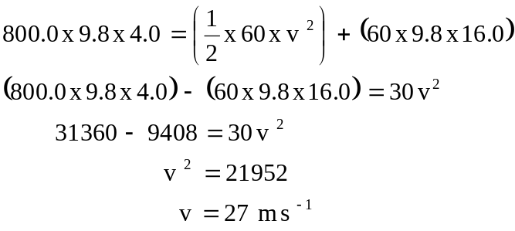

(g) The range of the missile would be increased. The increased mass of the counterweight would increase the magnitude of the LHS of the equation so the launch velocity would be increased. If the launch velocity is increased then the missile is in the air for longer and therefore the range will be increased.

